Book
Title

AUTHOR NAME

Copyright © 2012 Author Name
All rights reserved.
ISBN:

Acknowledgements

I would like to thank my parents for helping me author my first book.

I would like to thank my brother in helping me inspire write this book and publish.

Table of contents

Chapter 1
Chapter 2

Introduction

California is one of the biggest state in the US. In this book we will go over the big cities in California and some great places to visit.

To add pictures refer to this video :

https://www.youtube.com/watch?v=GTkpg0pviDw

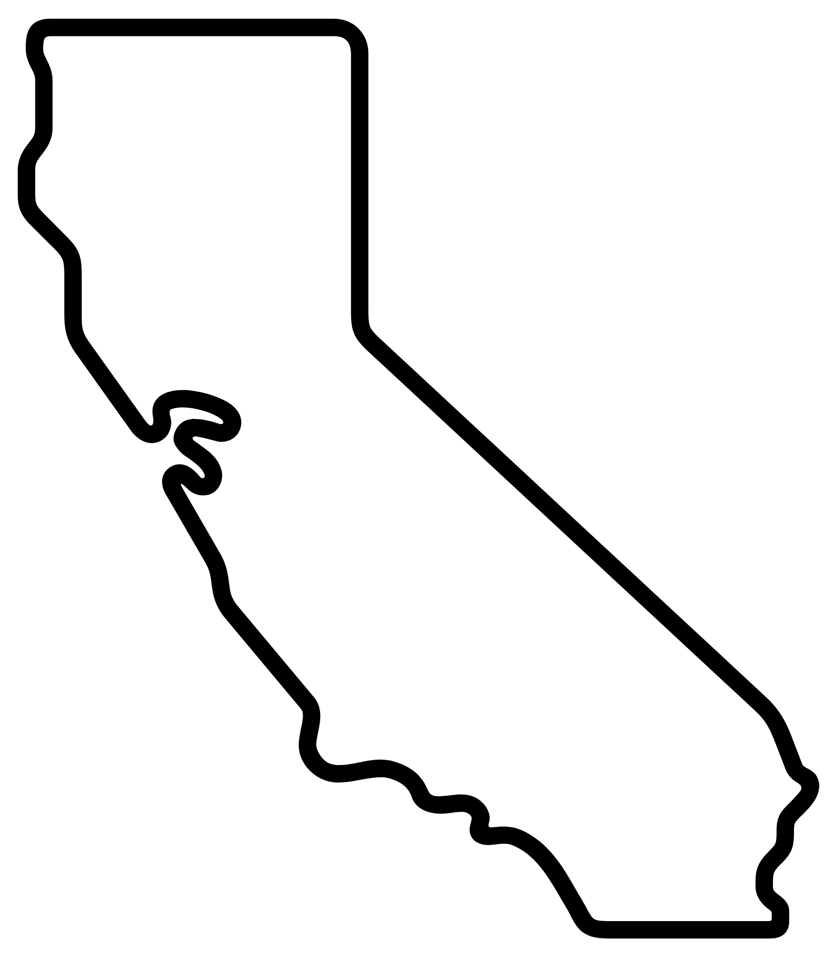

San Francisco

San Francisco is a great city.

Insert the picture

San Jose

Los Angles

.

San Diego

Hollywood

Sacramento

.

Cupertino

.

Yosemite

Disney Land

Silicon valley

Orange county

Pal Alto

Places to visit

.

ABOUT THE AUTHOR

Bob is in fifth grade at School, State. I love reading books and playing games.

